Amazon | OA 2020 | Labeling System

LEETCODE : <https://leetcode.com/discuss/interview-question/893442/>

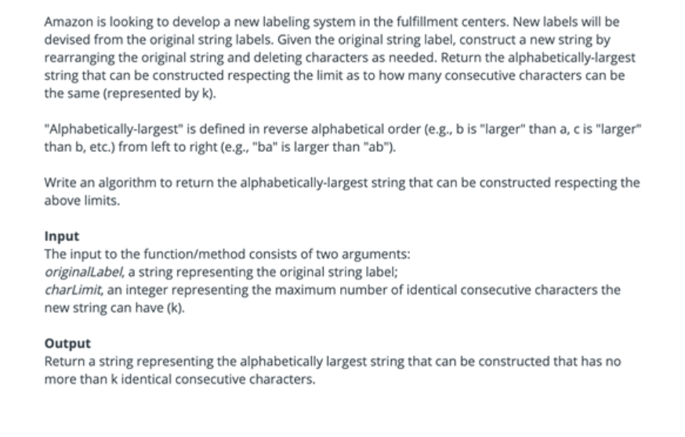

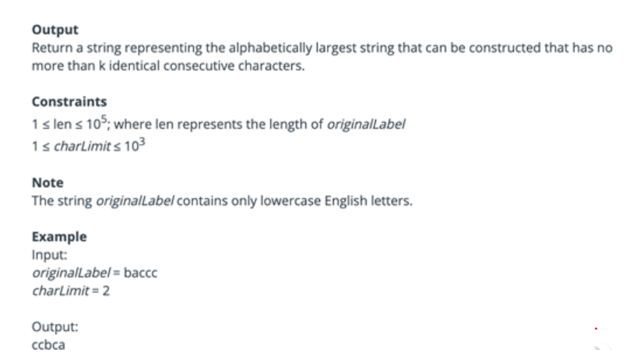

Java Greedy

public static String newLabel(String originalLabel, int limit) {

int n = originalLabel.length();

int[] charset = new int[128];

for (int i = 0; i < n; i++) {

charset[originalLabel.charAt(i)]++;

}

StringBuilder newLabel = new StringBuilder(n);

for (int i = charset.length - 1; i >= 0; i--) {

int count = 0;

while (charset[i] > 0) {

newLabel.append((char) i);

charset[i]--;

count++;

if (charset[i] > 0 && count == limit) {

Character next = nextAvailableChar(charset, i);

if (next == null) return newLabel.toString();

newLabel.append(next);

count = 0;

}

}

}

return newLabel.toString();

}

private static Character nextAvailableChar(int[] charset, int start) {

for (int i = start - 1; i >= 0; i--) {

if (charset[i] > 0) {

charset[i]--;

return (char) i;

}

}

return null;

}